**Eli Blain** 009136125

**Paul Aldana** 010503972

**Samuel Jacobs** 010168312



CECS 343 Team Project

T/Th 9:30am  
Due December 9, 2014

Use Cases and  
 user stories

Project Team 8 Iteration 3 Documentation

Table of Contents

Class Diagrams 1

Use Cases 2

Add a song to the database 2

Delete a song from the database 3

Drop a table from the database 3

Add a table to the database 3

Connect to the database 4

Creating a playlist 4

Adding song(s) to a playlist 5

Moving a playlist to a new window 5

Deleting a playlist 6

Context menu for toggling columns to display or not 6

Toggle columns to display or not 7

Column configuration persistence 7

Sort songs in the library 8

Timers and progress bar 8

Play Recent 9

User Stories Index Cards 10

Start Application 10

Play a song from MP3 file 10

Stop playing a song 11

Pause playing a song 11

Unpause playing a song 12

Skip to the next song (and play it) in the library 12

Skip to the previous song (and play it) in the library 13

Standard Menu Entries for: 13

Add a song to the library 14

Delete a song from the library 14

Drag and drop one or more songs that are added to the database 15

Set up SQL database 15

Controls Menu16

Play 16

Next 16

Previous 17

Go to Current Song 17

Increase Volume 18

Decrease Volume 18

Shuffle 19

Repeat 19

# Class diagrams

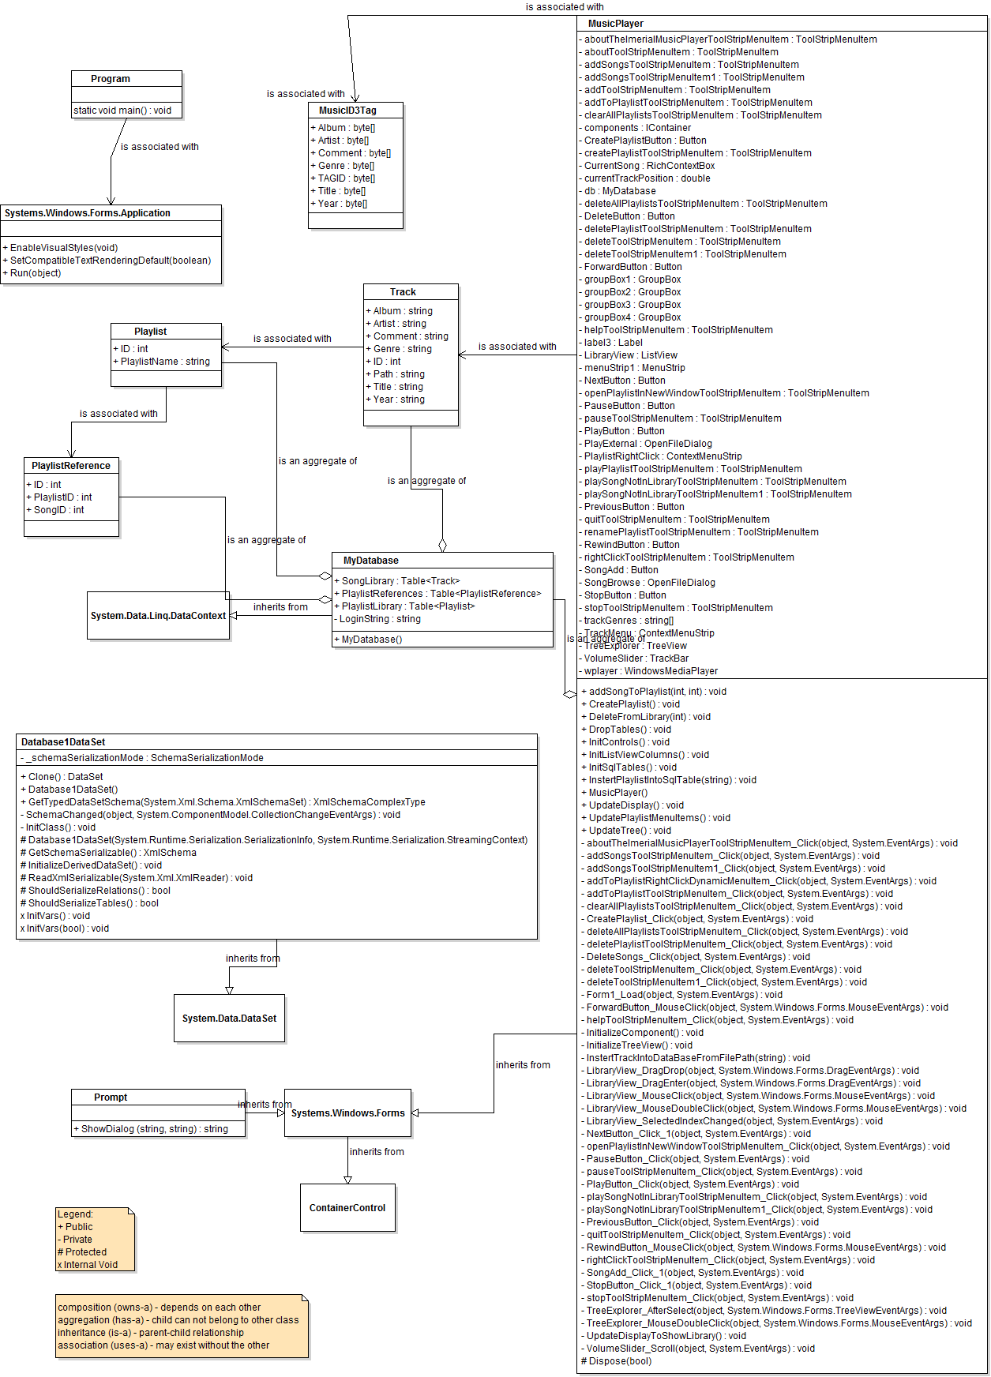

# Use Cases

## 

## add a song to the database

|  |  |
| --- | --- |
| Use Case | Add a song to the Database |
| Actor | MyTunes Application |
| Pre-Conditions | * The application has already established a connection to the database |
| Post-Conditions | * A song will be included in the database SongLibrary table * If the song is dragged into a playlist, it is also added to the playlist via PlaylistReferences Table. |
| Events | 1. The ‘File’ menu item is clicked 2. The ‘Add a Song’ menu item is clicked 3. A file explorer opens and the user selects a song 4. The application grabs the song data and parses through the IDv3 tag information 5. The application populates a ‘Track’ object to add to the database table, based on the tag information 6. The application executes a query that adds the song and updates the GUI to show the song library |
| Alt | 1. A song is drag-and-dropped into the song library or a playlist 2. The application grabs the song data and parses through the IDv3 tag information 3. The application populates a ‘Track’ object to add to the database table, based on the tag information 4. The application executes a query that adds the song and updates the GUI to show the song library or updated playlist |

## delete a song from the database

|  |  |
| --- | --- |
| Use Case | Delete a song from the Database |
| Actor | MyTunes Application |
| Pre-Conditions | * The application has already established a connection to the database |
| Post-Conditions | * A song will be deleted in the database SongLibrary table |
| Events | 1. The song is selected in the database 2. The ‘right-click’ menu is opened 3. The delete menu option is selected 4. The song is deleted from the database and cascaded through all tables 5. The song library or playlist view is updated accordingly |
| Alt | 1. The song is selected in the database 2. The ‘Delete’ button in the top left of the menu is clicked 3. The song is deleted from the database and cascaded through all tables 4. The song library or playlist view is updated accordingly |

## drop a table from the database

|  |  |
| --- | --- |
| Use Case | Drop a Table from the Database |
| Actor | MyTunes Application |
| Pre-Conditions | * The application has already established a connection to the database |
| Post-Conditions | * A table will be deleted from the database |
| Events | 1. The program will execute a query to drop a table while executing the constructor of the GUI. |

## add a table to the database

|  |  |
| --- | --- |
| Use Case | Add a Table to the Database |
| Actor | MyTunes Application |
| Pre-Conditions | * The application has already established a connection to the database |
| Post-Conditions | * A new table will be included in the database |
| Events | 1. The program will execute a query to drop a table while executing the constructor of the GUI. |

## connect to the database

|  |  |
| --- | --- |
| Use Case | Connect to the Database |
| Actor | MyTunes Application |
| Pre-Conditions | * The application has started and the parameters to connect are already established in the configuration file |
| Post-Conditions | * A connection will be established to the database |
| Events | 1. The connection is established upon instantiating the ‘MyDatabase’ object in the application. |

## CREATING A PLAYLIST

|  |  |
| --- | --- |
| Use Case | Creating a Playlist |
| Actor | User |
| Pre-Conditions | * The application must be running |
| Post-Conditions | * A new blank song playlist, named by the user, is created and added to the “Playlist” collapsible tree on the left panel of the music player wherein user could later add songs to the playlist. * The newly created playlist will be opened in the main library table component. * Playlist names and contents are in the relational database and accessed via SQL. * The library pulls all songs from the SongLibrary table while any playlist is accessed by using the PlaylistReferences table and associating a song id with a playlist id. |
| Events | 1. The user can use the “Create Playlist”from the “File” menu to create a new playlist. 2. User is prompted to enter the name of the playlist to be created. 3. Playlist is created and added to the playlist tree. 4. Playlist created will be opened in the main library table component. |
| Alt | 1a. The user can right-click on the library table and click “CreatePlaylist”from  the context menu to create a new playlist. |

## 

## adding song(s) to a playlist

|  |  |
| --- | --- |
| Use Case | Adding Song(s) to a Playlist |
| Actor | User |
| Pre-Conditions | * The application must be running * Song playlist must exists |
| Post-Conditions | * The selected song is added to the playlist. * If the added song(s) is/are not in the library yet, the song(s) will be added to the song library automatically. If the song is dragged into a playlist, it is also added to the playlist via PlaylistReferences Table. |
| Events | 1. The user can select a song from the library and right click. A context menu would have an entry named *Add to Playlist* wherein once hovered over, the user is prompted to select from a list of all the different playlists existing. 2. Selecting one of the playlist will add the selected song to the said playlist. 3. The song added will be visible in the playlist. |
| Alt | 1a. Drag and drop a song or songs from the library into the music playlist panel  on the left side of the music player.  1b. Drag and drop a song or songs outside of the music player which is not yet in  the library into the music playlist.  1c. Drag and drop songs from the library into the playlist which is opened in a  separate window. |

## Moving a playlist to a new window

|  |  |
| --- | --- |
| Use Case | Moving a Playlist to a New Window |
| Actor | User and MyTunes application |
| Pre-Conditions | * The application must be running * Song playlist must exists   + Playlist may be empty |
| Post-Conditions | * Playlist will be opened into a new window complete with its own audio control but no playlist and library trees. * Main window would display the song library |
| Events | 1. User selects a playlist in the playlist tree on the left panel. 2. User may right-click on the playlist and a context menu will show with the “Open in New Window” option. 3. User selects the “Open in New Window” option. 4. MyTunes application will open the new playlist in a separate window. |

## deleting a playlist

|  |  |
| --- | --- |
| Use Case | Deleting a Playlist |
| Actor | User |
| Pre-Conditions | * The application must be running * Song playlist must exists * Playlist to be deleted must be selected |
| Post-Conditions | * The selected playlist is deleted and the playlist tree is updated without the deleted playlist. |
| Events | 1. The user selects the playlist to be deleted. 2. Pressing the right-click mouse button would show a popup context menu with a “Delete Playlist” option. 3. Selecting this option would delete the playlist from the playlist tree on the left panel. |

## Context menu for toggling columns to display or not

|  |  |
| --- | --- |
| Use Case | Context Menu for Toggling Columns to Display or Not |
| Actor | User and MyTunes application |
| Pre-Conditions | * The application must be running |
| Post-Conditions | * A context menu is generated by the MyTunes application which allows the user from choosing which of the table columns will be displayed on the song table. |
| Events | 1. The user pressed right click on any of the title headers. 2. MyTunes application generates a context menu which has selectable fields listed permanently in the popup and each has a “checkbox” next to the column name. |

## Toggle Columns to display or not

|  |  |
| --- | --- |
| Use Case | Toggle Columns to Display or Not |
| Actor | User and MyTunes Application |
| Pre-Conditions | * The application must be running |
| Post-Conditions | * The checked columns are displayed on the song table and are consistent with the music library’s and playlist’s song table. The unchecked columns are hidden and the song table automatically resizes itself. |
| Events | 1. The user pressed right click on any of the title headers. 2. MyTunes application generates a context menu which has selectable fields listed permanently in the popup and each has a “checkbox” next to the column name. 3. User will then have the option to check or uncheck the boxes of the specified columns 4. MyTunes application will display the checked boxes and hide the unchecked ones from the song table. |
| Alt | 3a. User unchecks all the columns  4a. MyTunes application will only have the title of the song column displayed in  the song table if all the checkboxes are unchecked in the context menu |

## Column Configuration Persistence

|  |  |
| --- | --- |
| Use Case | Column Configuration Persistence |
| Actor | User and MyTunes application |
| Pre-Conditions | * The application must be running |
| Post-Conditions | * Columns displayed are persistent between playlists and library and persists from session to session |
| Events | 1. User selects whichever columns he/she wanted to display in the song table 2. MyTunes application will display the checked columns 3. User selects any of the playlists from the playlist list on the left panel of the music player 4. MyTunes displays the playlist with the same column configuration as the song library |
| Alt | 3a. User opens the playlist in a new window, proceed to step 4. |

## sorts songs in the library

|  |  |
| --- | --- |
| Use Case | Sort Songs in the Library |
| Actor | User and MyTunes application |
| Pre-Conditions | * The application must be running * There must be songs in the library or playlist in order to see the sorting |
| Post-Conditions | * The list is assorted alphabetically, with ‘A’ starting at the top of the list, depending on the column the user wanted to sort. |
| Events | 1. User left-clicks one of the table headers (Title, Artist, Album, Year, Genre, or Comment) of the song table. 2. MyTunes application sorts the table alphabetically according to the table header that the user chooses to press. |

## Timers and progress bar

|  |  |
| --- | --- |
| Use Case | Timers and Progress Bar |
| Actor | MyTunes application |
| Pre-Conditions | * The application must be running * A song must be currently playing |
| Post-Conditions | * Left timer displays the elapsed time since the song began playing * Right timer displays the length of the song being played minus the elapsed time. * Progress bar fills up as the song plays. Initially “empty” then slowly fills up depending on the length of the song. |
| Events | 1. MyTunes display the elapsed time since the song began playing on the left timer. 2. MyTunes determine the length of the song being played minus the elapsed time and then display it on the right end timer. 3. MyTunes synchronizes the progress bar with the passing of time as a song plays. At the commencing of play, the progress bar is “empty” and then slowly fills up as the song plays. |
| Alt | 1a. The left timer would reset to 0:00 once a song completes or the user chooses  another song to play  2a. The right timer determines the new length of the song minus the elapsed  time every time the user chooses to play another song  3a. The progress bar would reset to “empty” every time the user chooses a new  song to play. |

## Play recent

|  |  |
| --- | --- |
| Use Case | Play Recent |
| Actor | User and MyTunes application |
| Pre-Conditions | * The application must be running * There must be a song or songs that have been played |
| Post-Conditions | * Song chosen from the drop-down sub-menu by the user will be played and will be on top of the recently played list the next time the Play Recent sub-menu is accessed. * If a song is played repeatedly, it will only have one entry in the Play Recent list (no duplication) * Songs played in shuffle are not put in the recently played list. * Play Recent list will be in the startup as was in the last shutdown. |
| Events | 1. User hovers the mouse pointer over the Play Recent from the Controls menu 2. MyTunes application generates a drop-down sub-menu that is going to show the list of the 10 recently played songs. 3. User chooses from the list of recently played songs 4. MyTunes plays the chosen song. 5. MyTunes place an entry of the song played in the Play Recent list. |
| Alt | 2a. If there are less than 10 songs recently played, only the number of songs  played will be displayed.  5a. If there are more than 10 songs recently played, only the 10 most recent  songs will be displayed. |

# User Stories Index Cards

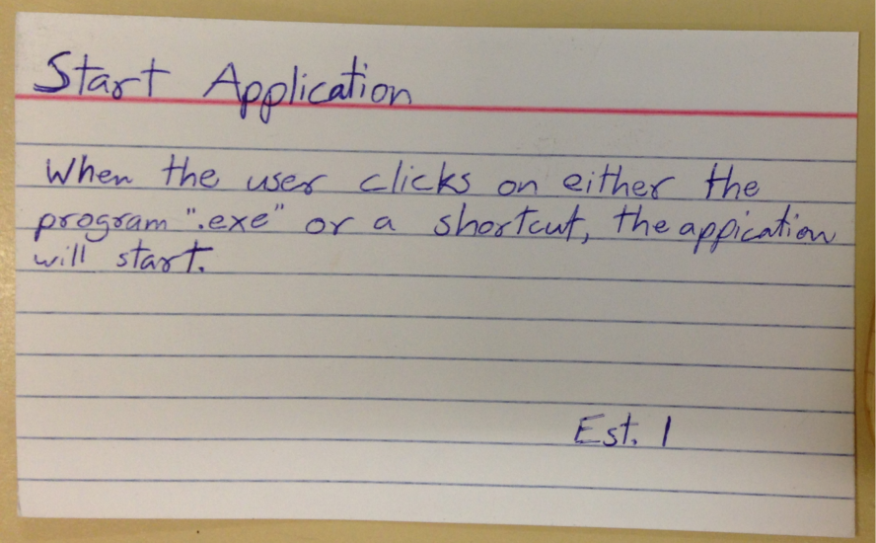

## Start Application

When the user clicks on either the program “.exe” or a shortcut, the application will start.

Estimated Day(s): 1

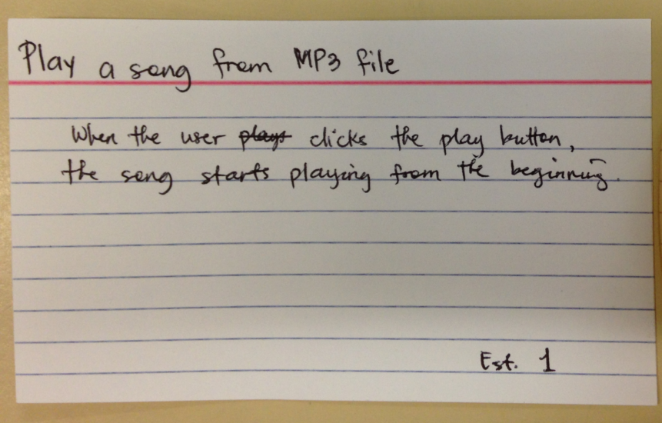

## Play a song from MP3 file

When the user clicks the play button, the song starts playing from the beginning.

Estimated Day(s): 1

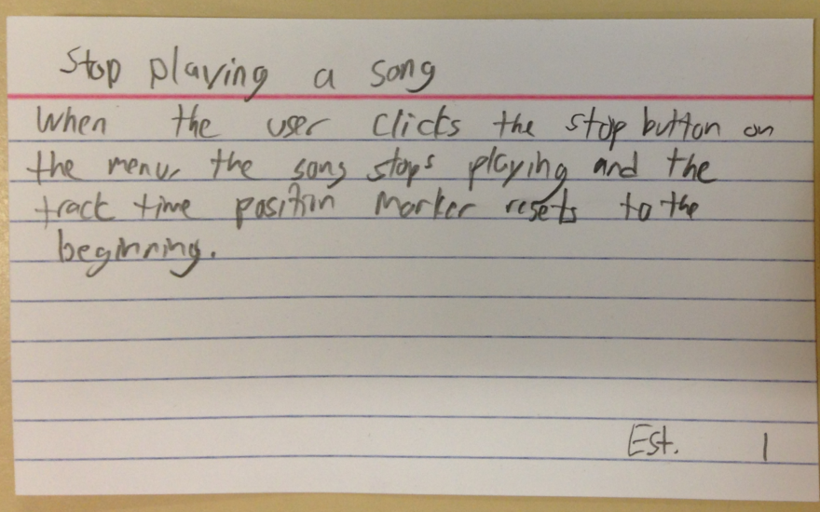

## Stop playing a song

When the user clicks the stop button on the menu, the song stops playing and the track time position marker resets to the beginning.

Estimated Day(s): 1

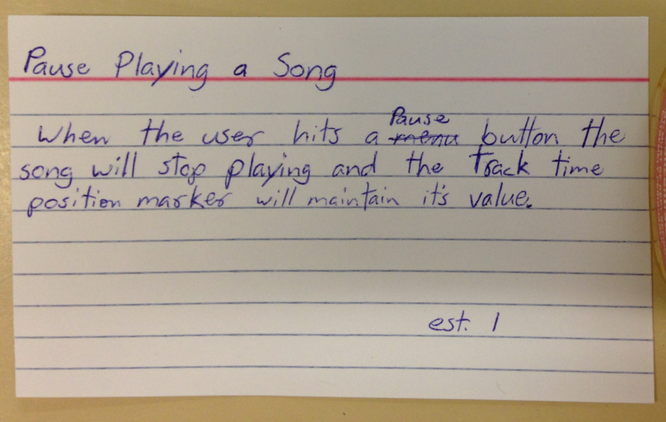

## Pause playing a song

When the user hits a pause button, the song will stop playing and the track time position marker will maintain its value.

Estimated Day(s): 1

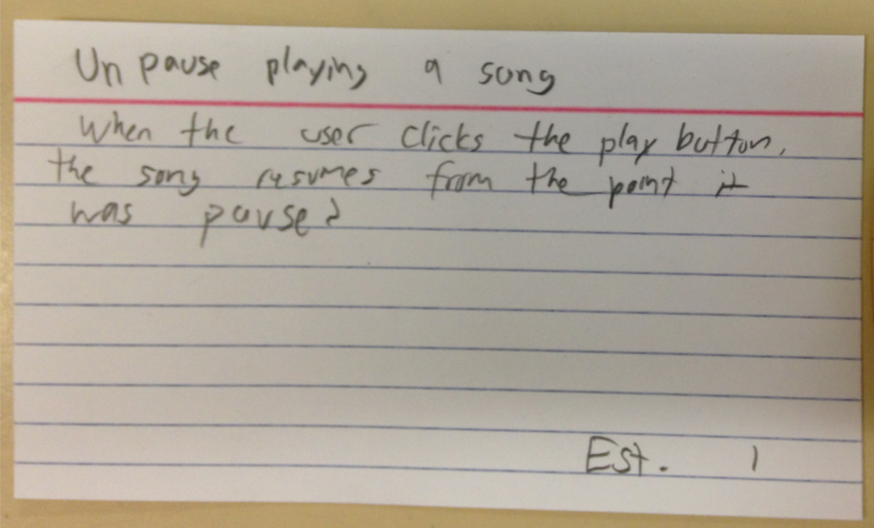

## Unpause playing a song

When the user clicks the play button, the song resumes from the point it was paused.

Estimated Day(s): 1

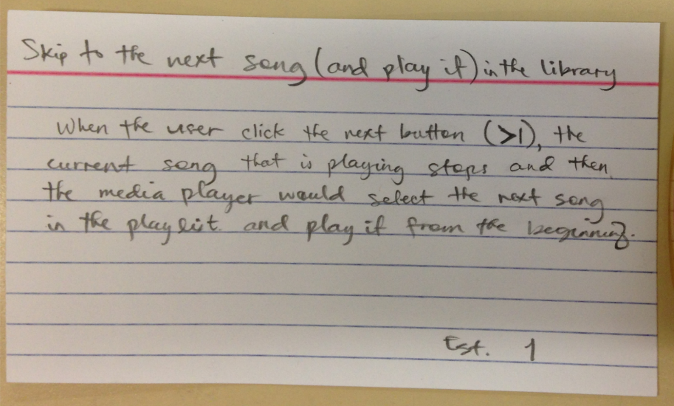

## Skip to the next song (and play it) in the library

When the user click the next button ( **>|** ), the current song that is playing stops and then the media player would select the next song in the playlist and play it from the beginning.

Estimated Day(s): 1

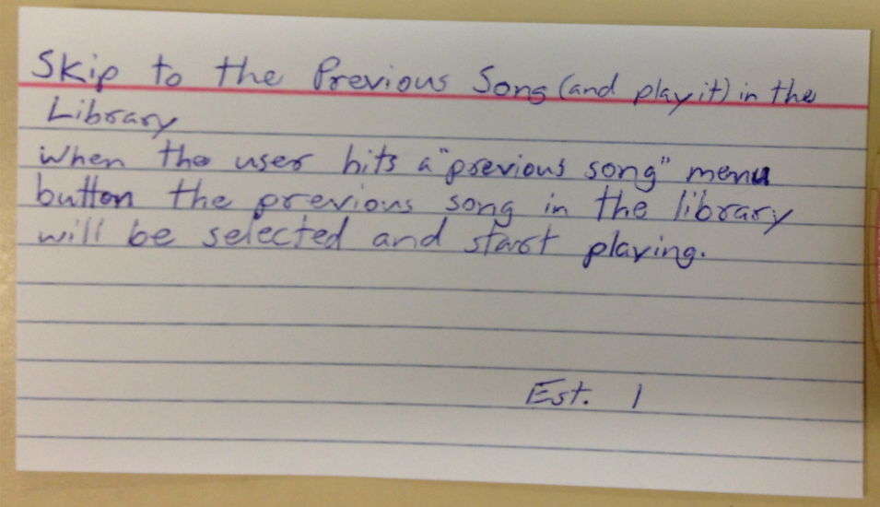

## Skip to the previous song (and play it) in the library

When the user hits a “previous song” menu button, the previous song in the library will be selected and start playing

Estimated Day(s): 1

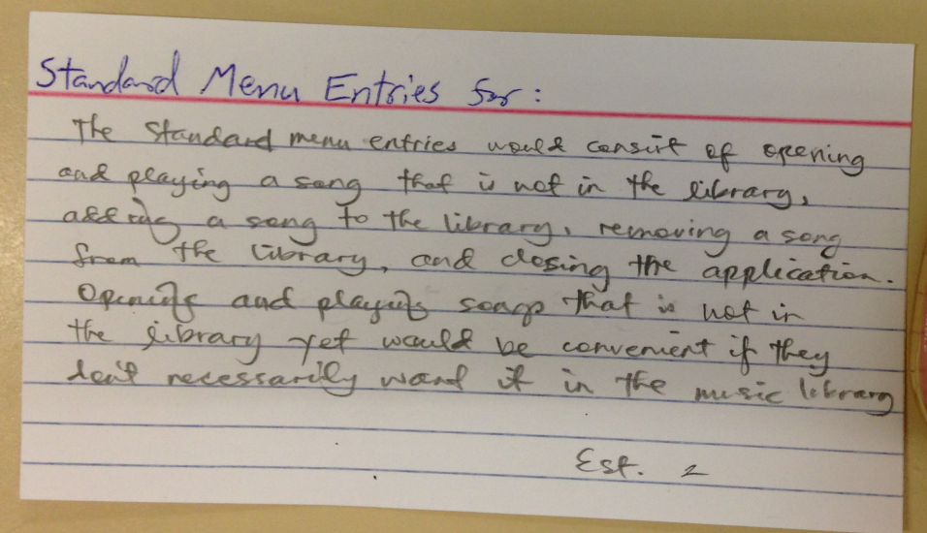

## Standard Menu Entries for:

The standard menu entries would consist of opening and playing a song that is not in the library, adding a song to the library, removing a song from the library, and closing the application. Opening and playing songs that is not yet in the library would be convenient if they don’t necessarily want it in the music library.

**Estimated Day(s):** 2

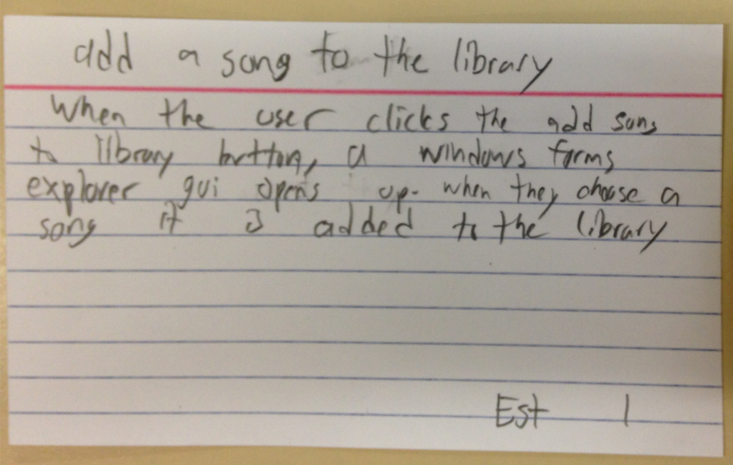

## Add a song to the library

When the user clicks the add song to the library button, a windows forms explorer GUI opens up. When they choose a song, it is added to the library

Estimated Day(s): 1

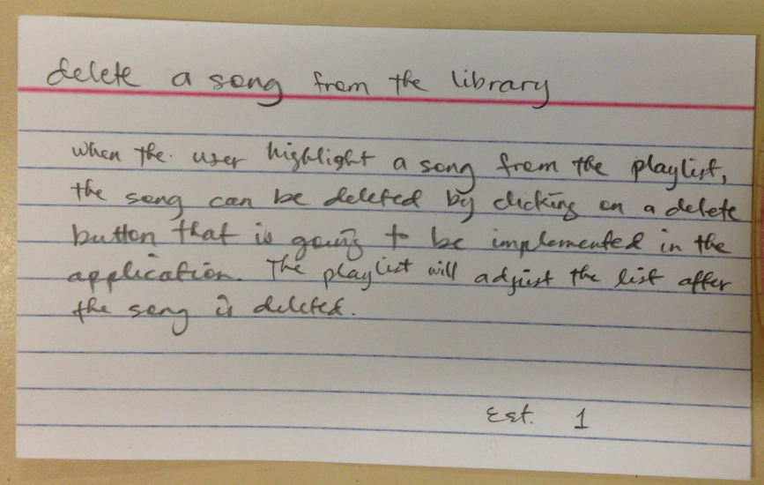

## Delete a song from the library

When the user highlights a song from the playlist, the song can be deleted by clicking on a delete button that is going to be implemented in the application. The playlist will adjust the list after the song is deleted.

Estimated Day(s): 1

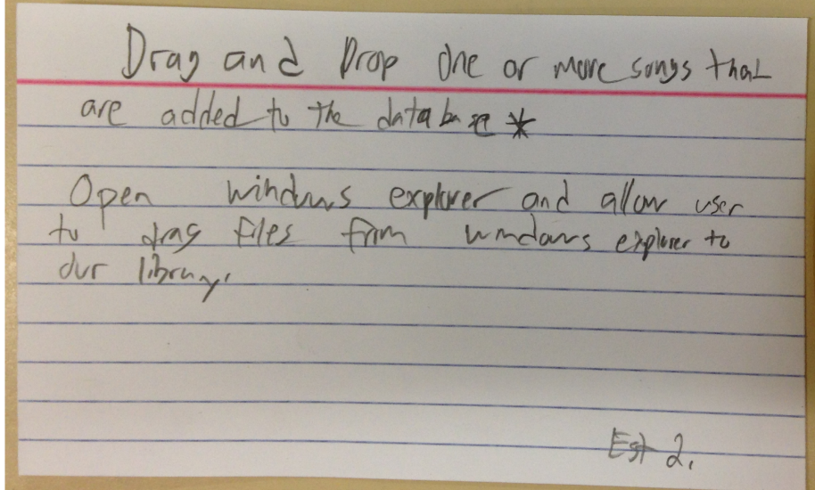

## Drag and drop one or more songs that are added to the database

Open windows explorer and allow user to drag files from windows to our library.

Estimated Day(s): 2

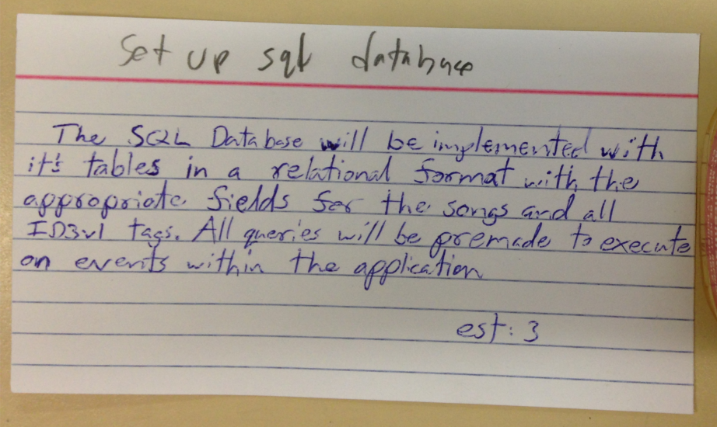

## Set up SQL database

The SQL database will be implemented with its tables in a relational format with the appropriate fields for the songs and all ID3v1 tags. All queries will be premade to execute an event within the application.

Estimated Day(s): 3

**Controls Menu User Stories**

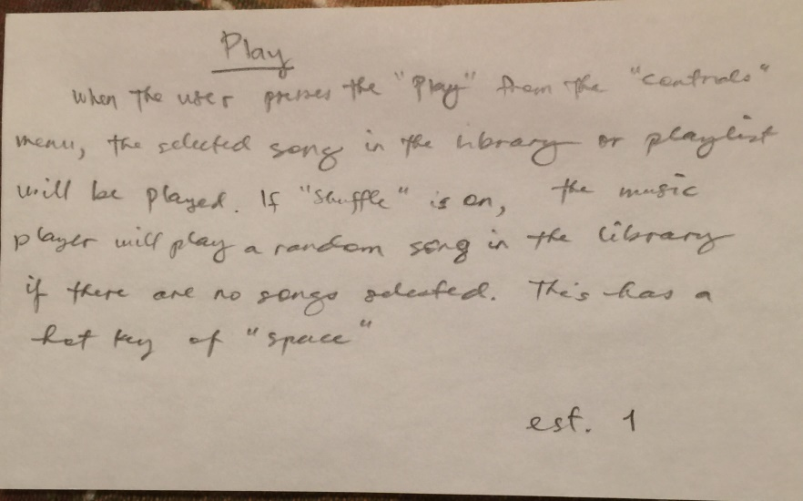

## PLAY

When the user presses the *Play* from the *Controls* menu, the selected song in the library or playlist will be played. If *Shuffle* is on, the music player will play a random song in the library if there are no songs selected. This has a hot key of “Space”.

Estimated Day(s): 1

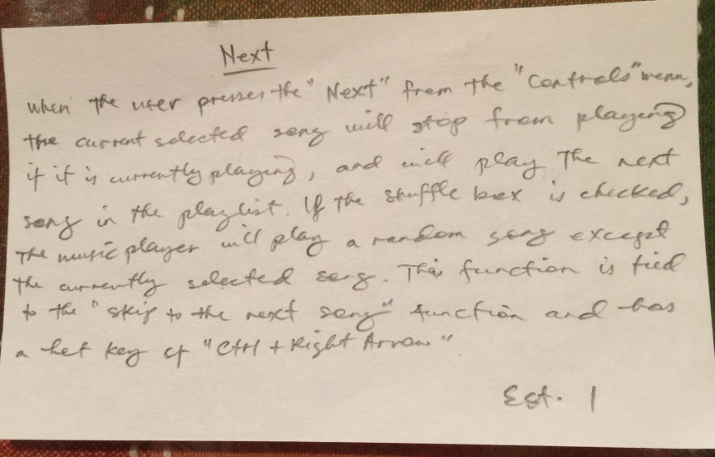

## NEXT

When the user presses the *Next* from the *Controls* menu, the current selected song will stop from playing if it is currently playing, and will play the next song in the playlist. If the shuffle check box is checked, the music player will play a random song except the currently selected song. This function is tied to the *Skip to the Next Song* function and has a hot key of “CTRL + Right Arrow”

Estimated Day(s): 1

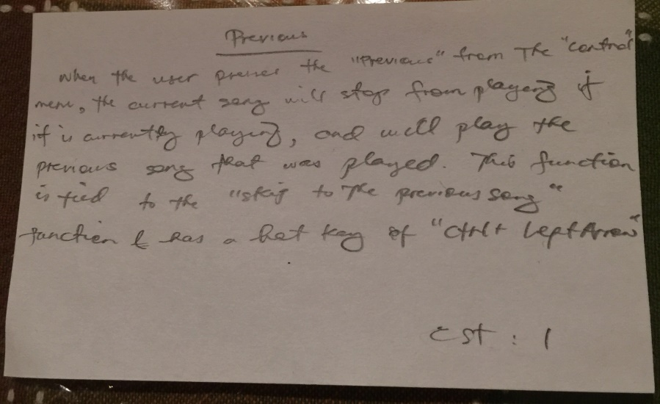

## Previous

When the user presses the *Previous* from the *Controls* menu, the current selected song will stop from playing if it is currently playing, and will play the previous song that was played. This function is tied to the *Skip to the Previous Song* function and has a hot key of “CTRL + Left Arrow”

Estimated Day(s): 1

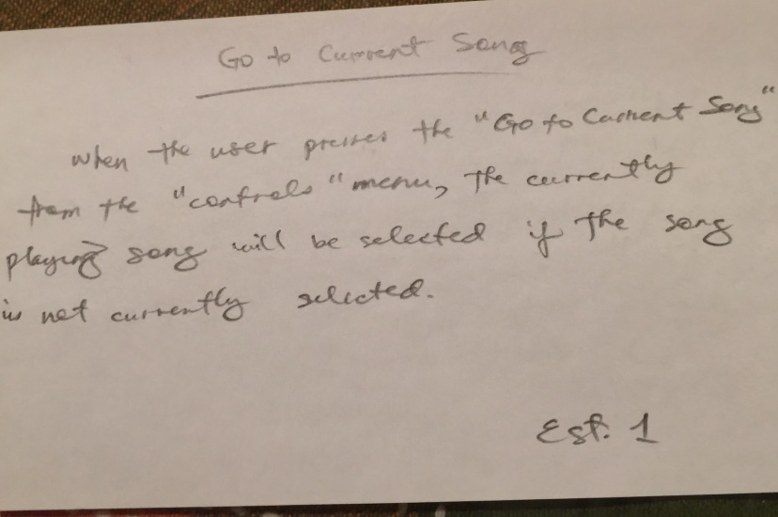

## Go to current song

When the user presses the *Go to Current Song* from the *Controls* menu, the currently playing song will be selected if the song is not currently selected.

Estimated Day(s): 1

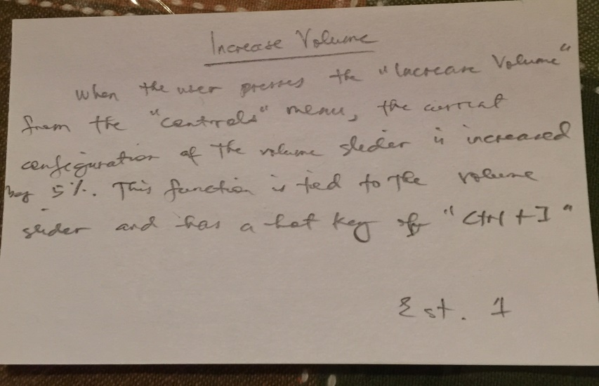

## Increase volume

When the user presses the *Increase Volume* from the *Controls* menu, the current configuration of the volume slider is increased by 5%. This function is tied to the *volume slider* and has a hot key of “CTRL + I”

Estimated Day(s): 1

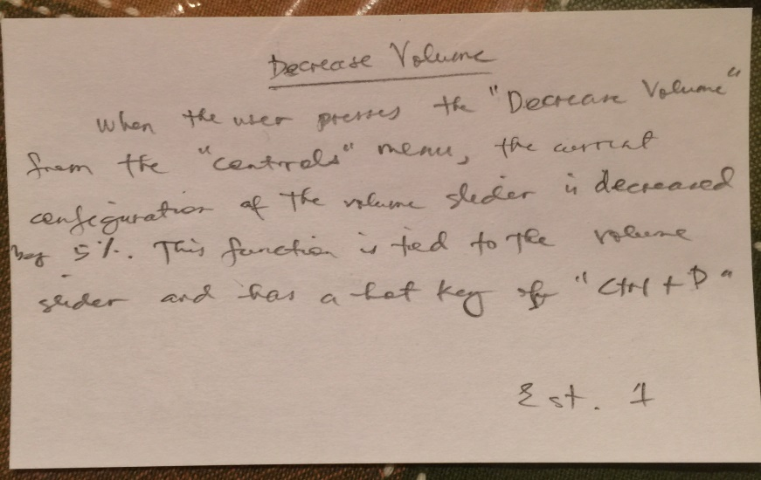

## Decrease Volume

When the user presses the *Decrease Volume* from the *Controls* menu, the current configuration of the volume slider is decreased by 5%. This function is tied to the *volume slider* and has a hot key of “CTRL + D”

Estimated Day(s): 1

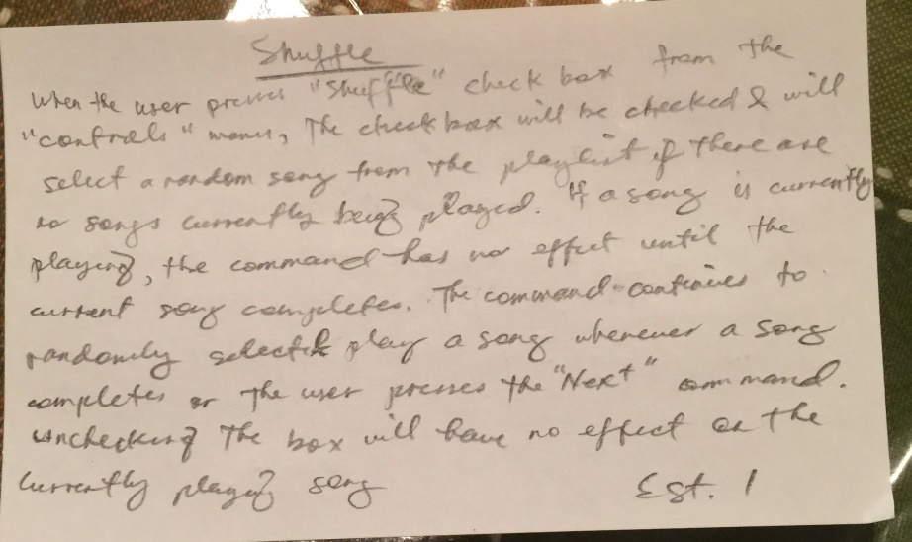

## shuffle

When the user presses the *Shuffle* checkbox from the *Controls* menu, the checkbox will be checked and will select a random song from the playlist if there are no songs currently being played. If a song is currently playing, the command has no effect until the current song completes. The command continues to randomly select and play a song whenever a song completes or the user presses the *Next* command. Unchecking the box will have no effect on the currently playing song.

Estimated Day(s): 1

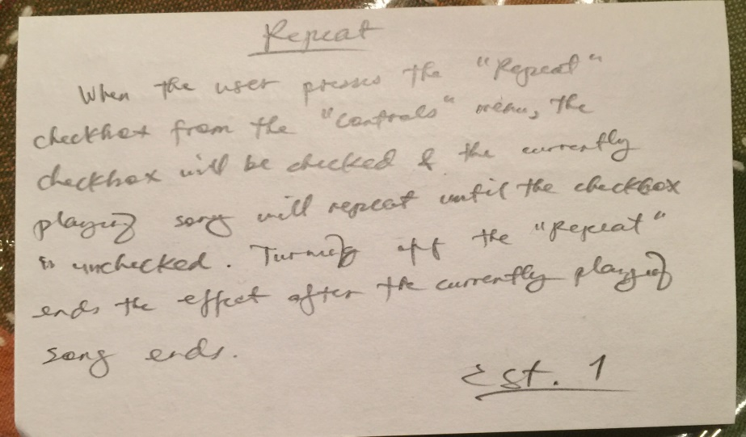

## Repeat

When the user presses the *Repeat* checkbox from the *Controls* menu, the checkbox will be checked and the currently playing song will repeat until the checkbox is unchecked. Turning off the *Repeat* ends the effect after the currently playing song ends.

Estimated Day(s): 1